ACSI Corporate Narrative

Architectural Cladding Services, Inc. has been providing Architects, Owners, Contractors, and Manufacturers with various consulting and design services relating specifically to curtain wall systems since 1991.
We maintain an efficient staff of Curtain Wall Consultants, Designers and Engineers, each having years of curtain wall experience projects including corporate headquarters, multi-tower complexes, and high rise buildings.
Steve Downey, the president of Architectural Cladding Services, has be involved in the curtain wall industry for over twenty years; being directly involved with the development and construction of façade systems on over one hundred fifty projects. With an expanding project base in Asia, Mr. Downey founded ACSI Limited in Hong Kong in 1995 to provide an Asian hub and expand the knowledge of different construction practices; knowledge which can only be gained by being part of the local professional community.
Wes Hansen, the Regional Manager of our US office, has a long history in the curtain wall industry and has worked on projects in Taiwan, England, Hong Kong, Singapore, Hawaii, Sri Lanka, as well as numerous projects in the continental US.
In 2001, ACSI Ltd. opened its office in Manila, again expanding the services as well as the knowledge base of a staff of experienced designers and engineers.
Today, the Hong Kong office alone maintains a staff with a combined curtain wall experience of over 80 years, providing one of the most knowledgeable resource of any Curtain Wall Consulting firms in Hong Kong.

Our Vision:

We will provide curtain wall consulting and design services of the highest quality in the external facade industry. We will be instrumental in the implementation of our client’s vision while insuring compliance with the highest quality of technical and performance requirements.

Our Mission:

We will provide the highest quality services in the architectural cladding industry by:
facilitating successful designs through faithful application of technical expertise and experience
insuring the reputation and integrity of our clients by maintaining an objective balance between architectural and technical requirements
providing practical design solutions for all project challenges ranging from the typical and simple to the most unique and difficult
facilitating more efficient means of design implementation

Our Values:

Adaptability: We will remain sensitive to the individual and diverse needs of our clients, and we are committed to adapting our knowledge and experience to meet specific client requirements.
Confidentiality: We will honor the proprietary rights of our client’s intellectual property as developed in a highly specialized and competitive market. We are committed to protecting all proprietary information.
Courtesy and Respect: We recognize and admire the hard earned expertise of our clients and we will show at all times our respect through a courteous and professional relationship.
Impartiality: We will endeavor at all times to utilize the best of our knowledge and experience for any given design challenge, but in the end, the client’s preferences will always take the highest possible priority.
Innovation and Improvement: We will endeavor to keep an open mind and be willing to accept new and innovative methods of design. We are eager to utilize the newest developments in codes and industry standards for the continued improvement of our client’s designs.
Integrity of Design: We will faithfully apply sound engineering principles, tempered with practical experience, to provide the highest attainable design quality for our clients.
Design and Engineering Services Provided

We provide full system design, engineering and production drawings for External Façade Systems for low-rise to high-rise buildings. ACSI offers these specific services:

Conceptual Design Development
Conceptual design development and summary with preliminary calculations
Tender document review summary
Structural review and design of new die profiles with full section properties
Basic system engineering with performance mockup calculations
Value Engineering
Existing system review for technical merit and compliance with all contract documents as well as applicable codes and standards
Application of the latest codes and standards to identify possible cost savings through the most efficient use of materials and labor
Full System Submission Drawings and Structural Engineering
Curtain Wall (stick built, unitized and hybrids)
Glass Wall (aluminium and/or steel truss and frame)
Metal Cladding (utilizing cost saving non-linear analysis techniques)
Stone Cladding (handset, precast and prefabricated steel truss)
Full Project Engineering Support
Providing Full System Engineering plus . . .
Ongoing system engineering applications
Technical support for BD and Consultant reviews
Specialized designs for on-site problems (remedial anchor conditions)
Site Inspections for QA programs
Production Drawings
Project 3D renderings
Fabrication Production Drawings
Material Quantities Takeoffs
Forensic Investigations for existing construction
Investigation and identification of current and potential problems
Recommendations for remedial corrective measures
Testing
Material Testing witness and report (aluminium, stone, anchor assemblies, etc.)
Full System Mockup review and summary

We provide engineering calculations in full compliance with the following standards: (sample listing only – numerous other codes are applied as needed)

British Codes & Standards
BS 6262: Standard for glass design
BS 8118: Latest code (supersedes BS CP 118) utilizing limit state design and plastic section properties resulting in significantly lighter and cost effective aluminium systems
BS 5950: Latest code utilizing limit state design and plastic section properties resulting in lighter cost effective steel systems
BS 3643, 3692, 4190, 6105: ISO fastener design application
China Codes & Standards
JGJ 102: New code for Glass Curtain Wall Engineering
GBJ 17: Standard for steel design – limit state
Hong Kong Codes & Standards
PNAP 106: Curtain Wall Systems
PNAP 139: Window and Window Wall
BS Standards (as listed above)
US Codes & Standards
AAMA: American Architectural Manufacturers Association
The Aluminum Association: Aluminium Design Manual
AISC: American Institute of Steel Construction
AISI: American Iron and Steel Institute
ASTM: American Society for Testing and Materials
GANA: Glass Association of North America
PCI: Precast and Prestressed Concrete Institute

We provide engineering calculations utilizing the best of traditional and new engineering principles and theory, and we present our calculations in presentation document format to facilitate smooth reviews and quick approvals. For example:

Limit State Design: Also known as LFRD in America (Load Factor Resistance Design), this method of design can offer significant cost savings over older ASD methods (Allowable Stress Design).
Non-Linear Analysis for Thin Plate Design.
Presentation Calculations: We use Mathcad Software (by MathSoft, Inc.) linked with AutoCAD to provide fully automated designs that are consistent and thorough, yet completely flexible for adaptation to an infinite number of design possibilities.
Project Narratives

ACSI has established a firm reputation of quality in design and consulting through out the USA, Hong Kong and China. The following is a brief sample of some of our projects.

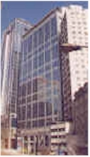
661 King's Road North Point, Hong Kong – A 34 story (150M) office building and a 34 story (103M) hotel complex completed in 1999 for Randash Investment. The façade systems incorporated laminated vision glass and monolithic spandrel glass in the office tower’s unitized curtain wall, and individual unitized vision and spandrel glass panels with infill aluminium cladding for the hotel facade. The podium works included a three story glass mullion (TVS) system, aluminium cladding and a 13 meter by 13 meter space frame canopy bridging between the two towers.

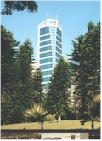
88 Hing Fat Street, North Point, Hong Kong is a 36 story (130M) office building completed in 2000 using a custom stick built curtain wall system and aluminum cladding. The curtain wall design includes vertical structural silicone glazing and integral tubular vertical architectural features which extend 8 meters above the top of the curtain wall.

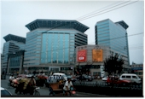
Beijing New World Centre, a development by Beijing Chong Wen and New World Properties Development Company Ltd. includes a hotel, residential units, office space, and a retail center. Dennis Lau & Ng Chun Man were the architects of this four tower complex which included curtain wall, window wall and granite systems. Inclusive of the architectural lantern feature crowning the project, the façade covered 40,000 square meters.

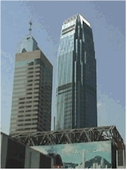
One International Finance Centre is the first tower of the world famous Central Waterfront Project in Central, Hong Kong. This 41 story (214M) office building in Hong Kong developed by Central Waterfront Property Development, Ltd. was completed in 1998. Working with Rocco Design Ltd., Cesar Pelli, Arup Facade as the owner’s consultant, and Chevalier (Aluminium Engineering) Ltd., this project stands as a main focal point of the Hong Kong skyline.

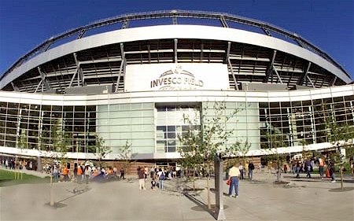
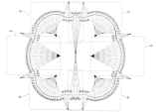

NFL Stadium for the Denver Broncos through our United States office is a great project we have as a subcontractor through Progressive, A-1 Glass and HNTB Sports Architects.

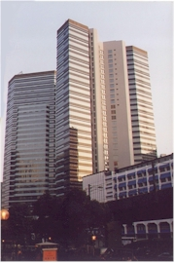
KTIL 192 / 81 Ho Ming Street, Kowloon, Hong Kong is a twin 30 story tower office complex, completed in 1998, developed by Hopley International Ltd. The architect on this notable building P&T Architects & Engineers, Ltd. The curtain wall with monolithic vision and spandrel glass and enamel cladding at the podium covered a total wall area of 50,000 Sq M.
KTIL 654 Kwun Tong, Kowloon, Hong Kong owned by Sun Hung Kai Group had CDU Architects Planners Ltd. and Meinhardt Facade consultants. The office building has a stick curtain wall with two sided vertical structural silicone covering a wall area of 13,000 Sq M.
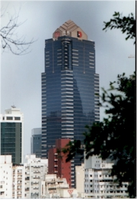

Millennium Plaza, including the 52 story Cosco Tower and the low block being a 28 story office tower consists of a 53,000 Sq M area hybrid curtain wall system with insulated vision glass and Cerafic Spandrel glass used on this monumental office complex. Developed by New World Development Company Ltd. we worked with Hsin Yeih Architects, Ltd and consultant CDC Ltd. for this unique curtain wall completed in 1997.

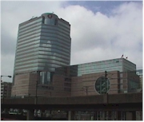
MTRC Headquarters is the 24 story office and retail space known as Telford Gardens Extension at Kowloon Bay. Working with architect Wong Tung & Partners we served as the curtain wall consultants on this 51,300 Sq M wall area project that consisted of a Unitized Curtain Wall, Unitized Window Wall with hand set granite.
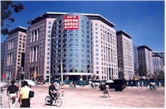
Oriental Plaza in Beijing, completed in 1999, is a large 200,000 Sq M area complex of eleven towers ranging from 14 to 24 stories (48M - 70M) of residential and office space with a hotel; developed by Chung Kong. Working closely with P&T Architects & Engineers, Ltd. and consultant Arup Façade, and Chevalier (Aluminium Engineering) Ltd., the thermally improved unitized curtain wall incorporated insulated vision glass, granite, aluminum cladding and barrel vault skylights with a monolithic spandrel with backpan. A critical erection schedule was met yet the system was proven to meet the stringent specification requirements of weather resistance, seismic design and thermal resistance.
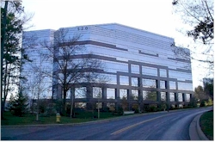
520 Maryville by Holleran Duitsman Architects, Inc. and Duke Reality Investments finished in 1999, this five-story, two-sided structural stick system office building with insulated vision glass and granite spandrel areas created a striking entrance with the horizontal bands of granite.

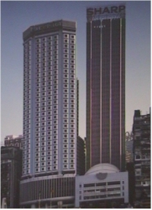
The Palace Mall, New World Salsbury Atrium is a retail space completed in 1998 located in Tsim Sha Tui, Kowloon. Owned by New World Development Company Ltd. this space-frame glass wall and skylight system had Kwan & Associates Architects Ltd. as the architects.

World Trade Centre in Causeway Bay, Hong Kong owned by Sun Hung Kai Group. P & T Architects & Engineers, Ltd worked with us on this 11,500 Sq M facade. The systems included stick built curtain wall incorporating integral state of the art lighting, column cladding, and aluminum wall cladding. This office project was completed in 1995.

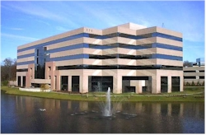
575 Maryville is Solutia’s office building in St. Louis, Missouri. The six-story unitized curtain wall with granite panels was designed as a suburban office setting by The Henderson Group Architect with Duke Reality Limited.

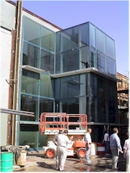

Cyberport, Telegraph Bay, Hong Kong - the heart of Hong Kong’s planed new “Silicone Valley”. ACSI worked closely with the Architect’s at Arquitectonica and Wong Tung Partners to develop a fully unitized curtain wall façade with unique lighting and features for this dynamic project. Development of the system took into special considerations including special patterned glass, large module widths, total vision wall concepts and a variety of sun shading profiles. Full performance testing was conducted at Construction Research Laboratories in Miami.

ACSI Key Staff CV’s


ACSI Limited, Hong Kong Office - Director
Architectural Cladding Services, Inc.,
USA Office - President and CEO

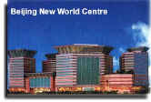
Steve has been involved in the development, management and construction of over 150 projects including cost sensitive low-rise structures, retail malls and monumental high rise buildings across the continental U.S., Hawaii, and Asia.

Steve's experience, spanning two decades, has helped him develop superior expertise in curtain wall building facades. He has provided expert testimony in litigated cases and technical advice to resolve contractual disputes.
His most recent experiences have included the technical design of the curtain wall systems of several of Hong Kong's most prestigious high-rise projects.



Centre Tower, Costa Mesa, California
Morrison Knudsen Headquarters, Boise, Idaho
Irvine Corporate Plaza a.k.a. Centre Tower, Irvine, California
Blue Cross Blue Shield Headquarters, Durham, North Carolina
Clinical Sciences Building, St. Louis, Missouri
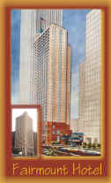
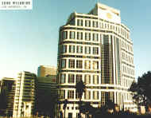
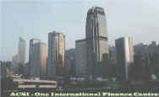
Jefferson State Office Building. Jefferson City, Missouri
Southwestern Bell Telephone Headquarters, St. Louis, Missouri
Prudential NW Business Campus, Minneapolis, Minnesota
Prudential Energy Project a.k.a. Enerplex, Princeton, New Jersey
1999 Broadway, Denver, Colorado
Intertech West, Denver, Colorado
Citadel Office Building, St. Louis, Missouri
900 N. Michigan, Chicago, Illinois
Raritan Plaza, Raritan, New Jersey
AT&T Town Pavilion, Kansas City, Missouri
Fox Plaza, Century City, California
One Denver Technical Center, Denver, Colorado
Crate & Barrel Headquarters, Northbrook, Illinois
1800 Grant Street, Denver Colorado
Eagle Gate Plaza, Salt lake City, Utah
Fairview Park, Fairfax, Virginia
Museum of Modern Art, New York, New York
1000 Wilshire Blvd., Los Angeles, California
Holiday Inn at Raritan, Raritan, New Jersey
Fairmont Hotel, Chicago, Illinois
American Medical Office, Washington D. C.
Koll Center Orange, Anaheim, California
1585 Broadway, New York, New York
Alemeda Towers, Kansas City, Missouri
712 5th Ave., New York, New York
Cobo Hall Expansion, Detroit, Michigan
Koll Center San Diego, San Diego, California
Tysons II, Tysons Corner, Virginia
St. Lukes Hospital, Kansas City, Missouri
Equitable Building, Chicago, Illinois
Renaissance Square, Phoenix, Arizona
Temple RLDS, Independence, Missouri
Daytona Beech Marriott, Daytona Beech, Florida
New Orleans Airport Hilton, Kenner, Louisiana
Waikiki Landmark, Waikiki, Hawaii
University Mall, Carbondale, Illinois
Lindenwood Apartments, Cape Giradeau, Missouri
Corporate Place, Tulsa, Oklahoma
Kelly Field Bank, San Antonio, Texas
Wanchai Towers 1,2 & 3, Wanchai, Hong Kong
Regional Council Chambers and R.S.D. Headquarters, Sha Tin, Hong Kong
Kwun Tong Lawcourts Building, Kwun Tong, Hong Kong
Tuen Mun Lawcourts Building, Tuen Mun, Hong Kong
Harbour Building, Central, Hong Kong
The Waterford, New York, New York
North Point, Philadelphia, Pennsylvania
Blvd. 40, Addison, Illinois
Lighton Tower, Overland Park, Kansas
Ontario Place, Chicago, Illinois
Liberty Street Office Building, Reno, Nevada
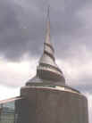



Member of Glass Association of North America
Member of the American Society of Testing and Materials (ASTM),
E-6 Committee on Performance of Buildings
Member of the International Conference of Building Materials (ICBO)
Member of the Building Environment & Thermal Envelope Council (BETEC)
Former Domestic and International Project Manager for
Heitmann & Associates, Professional Cladding Consultants
Former Senior Associate with Kovarik & Associates, Civil Engineers
and Project Developers.

Architectural Cladding Services, Inc., USA Office Regional Manager


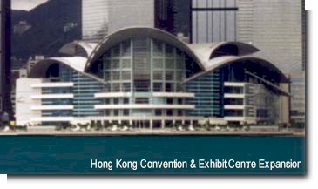

Wes, a curtain wall consultant for over 15 years, has engaged in the development, management, and construction of more than fifty projects across the continental U.S., Hawaii, and Asia. Providing instruction to the architectural division of the Hong Kong government, Wes addressed the fundamentals on the proper design and installation of curtain wall systems. He also coordinated the writing of the General Curtain Wall Specification for new Hong Kong government projects. Wes is the Regional Manager for our North American Headquarters.

One International Place, Boston, Massachusetts
One Magnificent Mile, Chicago, Illinois
Momentum Place,Dallas, Texas
Southwestern Bell Telephone Headquarters, St. Louis, Missouri
Fox Plaza, Century City, California
NEA Building, Washington D. C.
1585 Broadway, New York, New York
712 5th Ave., New York, New York
320 Park Avenue, New York, New York
Sioux City Art Center, Sioux City, Iowa
9 West 57th Street, New York, New York
750 7th Avenue, New York, New York
527 Madison Avenue, New York, New York
One First National Plaza, Chicago, Illinois
Townsend Place, Kansas City, Missouri
Allsup Building, Belleville, Illinois
Buckeye International Building, St. Louis, Missouri
Ambulatory Patient Care Building, Birmingham, Alabama
Maryland Place, St. Louis, Missouri
Waikiki Landmark, Waikiki, Hawaii
125 High Street, Boston, Massachusetts
One Corporate Plaza, Louisville, Kentucky
New African American Museum, Detroit, Michigan
First National Tower, Louisville, Kentucky
Massachusetts General Hospital Building 2, Boston, Massachusetts
Lambert International Airport, St. Louis, Missouri
Kwun Tong KTIL-192, Kwun Tong, Hong Kong
Wanchai Towers 1,2 & 3, Wanchai, Hong Kong
Regional Council Chambers and R.S.D. Headquarters, Sha Tin, Hong Kong
T&C Tower, Kaohsiung, Taiwan
Hong Kong Convention and Exhibit Centre, Wanchai, Hong Kong
HKCEC Extension, Wanchai, Hong Kong
Central Plaza, Central, Hong Kong
Hong Kong Temple, Hong Kong
Echelon Square, Colombo, Sri Lanka
Pacific Place (Phase 2), Wanchai, Hong Kong
Combined Operations Airport Building, London, England
Hang Seng Bank, Central, Hong Kong
Grand Central Plaza, Sha Tin, Hong Kong
Lane Crawford Building, Singapore, Singapore
No. 9 Ice House Street, Central, Hong Kong
International Finance Center, Central, Hong Kong

Curtain wall consulting services on Peninsula Hotel Extension, an office/hotel tower in Kowloon, Hong Kong. Duties included:- Development of conceptual curtain wall details for the Architect
- Review subcontractor proposals for technical merit
- Review subcontractor project shop drawings
- Monitor full scale mock-up erection and testing in Hong Kong
- Conduct on site inspections for curtain wall installation
- Conduct on site water infiltration tests
Curtain wall consulting services on Hong Kong Convention and Exhibition Center, a multi-use building complex in Wanchai, Hong Kong. Duties Included:
- Development of conceptual curtain wall details for the Architect
- Review subcontractor proposals for technical merit
- Review subcontractor project shop drawings
- Monitor full scale mock-up erection and testing in the USA & Hong Kong
- Conduct on site inspections for curtain wall installation
- Conduct on site water infiltration tests

Member of the American Society of Testing and Materials (ASTM)
Former Domestic and International Senior Staff Member for
Heitmann & Associates, Cladding Consultants
Associate in Applied Science/Architectural and Building
Engineering Technology, Vermont Technical College
Bachelor of Architecture, Kansas State University

ACSI Limited, Hong Kong Office Engineering Manager

EXPERIENCE SUMMARY
Registered Professional Engineer with 17 years experience in the specialization of Architectural Cladding Systems. Fully qualified in all phases of design, engineering and inspection for custom systems in glass, metal and stone cladding. Fully experienced in the design and coordination of backup structural systems associated with cladding support, including steel, concrete and masonry. Familiarity with all phases of fabrication, erection and testing allows for effective project management from tendering to project completion. Glass design experience includes all forms of curtain wall (stick built, unitized and hybrid systems). Stone cladding design experience includes all types of stone fully integrated into curtain wall as well as handset and prefabricated steel truss systems. Thorough engineering design proficiency for architectural cladding systems using four sets of codes and standards – British, China, Hong Kong and U.S.

The Crescent, (Office, Hotel & Retail Complex) Dallas Texas Stone Clad
One Ferris Plaza (Belo building), Dallas, Texas Stone Clad
Las Colinas Regent Inn & Conference Center, Irving, Texas Masonry Clad
Las Colinas Fitness Center & Spa, Irving, Texas Masonry Clad
Meyerson Symphony Hall, Dallas, Texas Stone Clad
IBM Tower, Atlanta, Georgia Stone Clad
Greenhill Office Park, Phase II, Dallas, Texas Masonry Clad
City Place Center, Dallas, Texas Stone Clad
900 North Michigan, Chicago, Illinois Stone Clad
Strong/Corneliuson Headquarter, Milwaukee, Wisconsin Stone Clad
Norwest Center, Minneapolis, Minnesota Stone Clad
Ridgeview Office Building, Dallas, Texas Masonry Clad
225 W. Wacker, Chicago, Illinois Stone Clad
Gateway Development, Building One, Atlanta Georgia Stone Clad
Aberdeen Office, Dallas, Texas Stone Clad
Premier Place, Dallas, Texas Stone Clad
Renaissance Tower, Sacramento, California Stone Clad
777 Tower, Los Angeles, California Stone Clad
Armand Hammer Museum, Los Angeles, California Stone Clad
Southern California Gas Center, Los Angeles, California Stone Clad
Oryx Center, Dallas, Texas Stone Clad
1250 "H" Street, Washington, D.C. Stone Clad
Gannett Building, Washington, D.C. Stone Clad
First Bank Place, Minneapolis, Minnesota Stone Clad
One Independence Square, Washington, D.C. Stone Clad
Austrian Chancery, Washington, D.C. Stone Clad
Judiciary Office Building, Washington, D.C. Stone Clad
Hamon Museum (Dallas Museum of Art Expansion), Dallas, Texas Stone Clad
Scottish Rite Hospital, Dallas, Texas Masonry Clad
J. Paul Getty Museum, Los Angeles, California Stone Clad
Brook Army Medical Center, San Antonio, Texas Masonry Clad
MTA Headquarters, Los Angeles, California Stone Clad
Exxon World Headquarters, Dallas, Texas Stone Clad
Silicone Graphics, Mountainview, California Curtain Wall
Wachovia Bank Tower, Winston Salem, N.C. Curtain Wall
DCSC Project, Columbus, Ohio Curtain Wall
George Bush Library, College Station, Texas Stone Clad
U.S. Courthouse, Sacramento, California Curtain Wall
Owens Corning World Headquarters, Toledo, Ohio Curtain Wall
U.S. Courthouse, Portland, Oregon Curtain Wall

Recent Asian projects include:
DCH Redevelopment, Quarry Bay, Hong Kong Curtain Wall
Festival Walk Commercial Development, Kowloon Glass Wall
Proposed Commercial Dev’t, Tin Shui Wai, Hong Kong Canopy
Hang Seng Bank Development, Causeway Bay, Hong Kong Canopy
Cathay Pacific Chek Lap Kok Headquarters Development, Lantau Curtain Wall
KTIL 654, Kwun Tong, Kowloon. Curtain Wall
KTIL 192, Kwun Tong, Kowloon. Curtain Wall
Hong Kong Station Development, IFC One, Hong Kong Curtain Wall
661 King’s Road, Hotel & Office, North Point, Hong Kong Curtain Wall
Oriental Plaza, Beijing, P.R.C. Curtain Wall
88 Hing Fat Street, North Point, Hong Kong Curtain Wall
Nina Towers, Tsuen Wan, New Territories Curtain Wall
Cyberport Development at Telegraph Bay, Pok Fu Lam Curtain Wall

Bachelor of Science, Civil Engineering
Registered Professional Engineer in the State of Texas
ACSI Limited, Hong Kong Office Design Consultant



Experience Summary

Working in Asia, Nat has been involved in several projects as a specialist in preparation of tender drawings as well as development of full production drawings. His ability to accurately visualize Architectural detail in three dimension provides strong support in the development and review of systems. He works well in coordinating the details and aspects of the project.

Cathay Pacific Flight Training Center, Chek Lap Kok
Dragonair Building, Chek Lap Kok
Cathay Pacific Headquarters Building, Chek Lap Kok.
Grand Central Building, Shatin N.T.
Harbor Front Office/Hotel Tower, Hung Hom Bay
Cyberport Development at Telegraph Bay

For all of your curtain wall design and consulting needs, visit us at www.curtainwall.com

Architectural Cladding Services, Inc.  4372 Casa Brazilia Court, Suite 100  St. Louis. MO 63129, USA  Phone: 1 314 894 4600  Fax: 1 314 892 7989 | ACSI, Ltd  20A One Capital Place  18 Luard Road  Wanchai, Hong Kong  Phone: 852 2973 0459  Fax: 852 2527 2400

